# EDP – best available redesign

# Hypothesis

Reducing the prominence of the EDP toggle or removing it altogether will increase continuance to purchase.

**Test objective**  
Increase checkout conversion   
 **Related KPI (s)**

|  |  |  |  |
| --- | --- | --- | --- |
| **Increase site conversion (general)**  Increase site conversion on desktop by 1%  Increase site conversion on mobile by 10%  Increase site conversion on tablet by 4% | **Increase EDP conversion (general)**  Increase EDP conversion on desktop by 6%  Increase EDP conversion on mobile by 10%  Increase EDP conversion on tablet by 3% | | **Increase checkout conversion by 6%**  **Increase Digital Ticket take-up by 3%**  **Other:** Increase incremental revenue |
| **Device types included** | | Domains included WAITING TO FIND OUT | |
| |  |  | | --- | --- | | **Desktop***SC_Laptop.png* | **Tablet**  SC_Tablet.png | | **Mobile**  SC_Mobile.png | **Apps**  SC_Mobile.png | | | |  |  | | --- | --- | | **Denmark** | **Norway** | | **Finland** | **Sweden** | | **Germany** | **Spain** | | **Netherlands** |  | |  |  | | |
|  | |  | |

**Targeting the Ticketmaster apps (embedded checkout)**

The variable **evar65** identifies when embedded checkout mode is running. This value should be used in Monetate to include or exclude app traffic from a test.

Indicate below whether **evar65** should be included or excluded for this test:

**Yes** –inclusion is required (test will appear in the apps)

**No** – exclusion is required (test will not appear in the apps)

**Note to Ticketmaster:** if inclusion is required, the app team will be responsible for sign off. Join **#ab-testing-apps** to share test details and coordinate sign off

**Target Audience** (if relevant)

* n/a

**List of variants**

Default

1. Remove the toggle
2. Change the toggle to a simple text link + copy variations
3. Existing button design + copy variations

**Use cases/considerations** (please include referenceable examples, where relevant)

* x

**Metrics**

**Required for all tests:**

* Revenue per variant

**Additional metrics:**

* Clicks on the toggle button/ link
* Clicks on EDP continue button
* Clicks on the Seatmap
* Purchase conversion
* Visits from EDP to: Your tickets > additional items > login> checkout> confirmation

### Desired segmentation of results (if relevant)

* Per device – Mobile, desktop
* Results per market

**Test event URLs**

**DE -** http://www.ticketmaster.de/event/DEMVVK04  
**DK –** http://www.billetnet.dk/event/365533   
**DK –** <http://www.billetnet.dk/event/396437> (real demo - credit card can be used)   
**FI –** http://www.lippupalvelu.fi/event/test-event-ei-myyntia-not-on-sale-lippuja/117127  **NL –** http://www.ticketmaster.nl/event/testvoorstelling-tickets/116999  **SE –** http://www.ticnet.se/event/DEMFUNK3

**EDP types to include/ exclude:**

Only events showing the new EDP Seatmap should be included in this test. The new Seatmap can be identified by the variable below:

**New Seatmap variable:** tm\_omn.eVar23='EDP Seatmap ‘

Examples:

<http://www.ticketmaster.de/event/andreas-gabalier-die-grosste-volksrocknroll-show-der-welt-part-iii-tickets/230039?language=en-us>

<http://www.ticketmaster.fi/event/valokeilassa-jari-sillanpaa-tickets/207853?language=en-us>

**Finland:**

[**http://www.ticketmaster.fi/event/peppi-pitkatossu-tickets/203697?language=en-us**](http://www.ticketmaster.fi/event/peppi-pitkatossu-tickets/203697?language=en-us)

**Germany:**

**http://www.ticketmaster.de/event/starlight-express-tickets/190419?language=en-us**

**Variant detail**

**Default (Control)**

**Desktop**

* The seatmap is displayed by default. The ‘find seats for me’ button displays the best available version of the EDP
* The toggle to best available appears on the right side above the seatmap
* If the user toggles to the best available view, the copy and icon on the button changes to the seatmap version. Clicking the button again will switch back to the seatmap view

**Seatmap view:**

**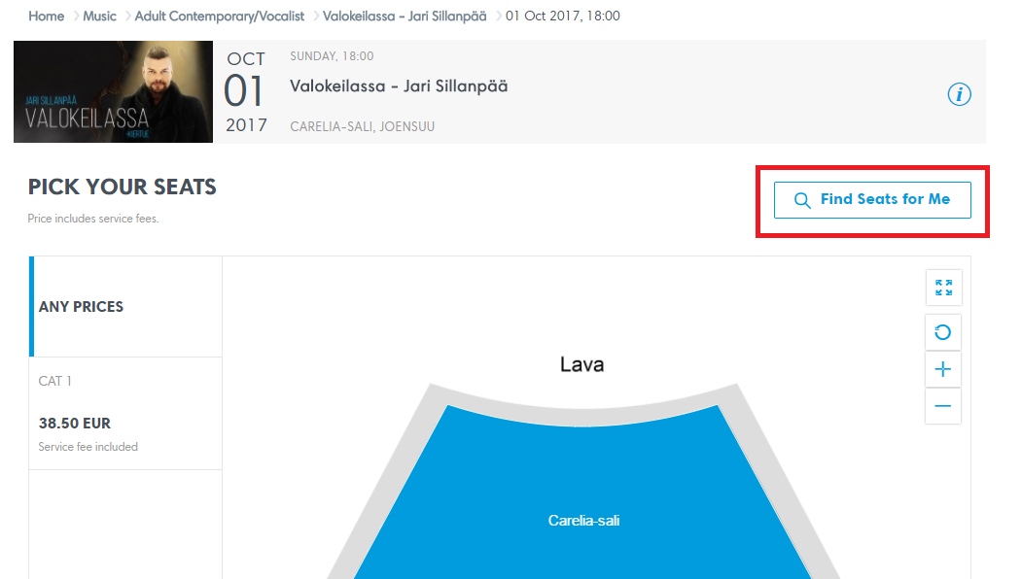**

**Best available view:**

**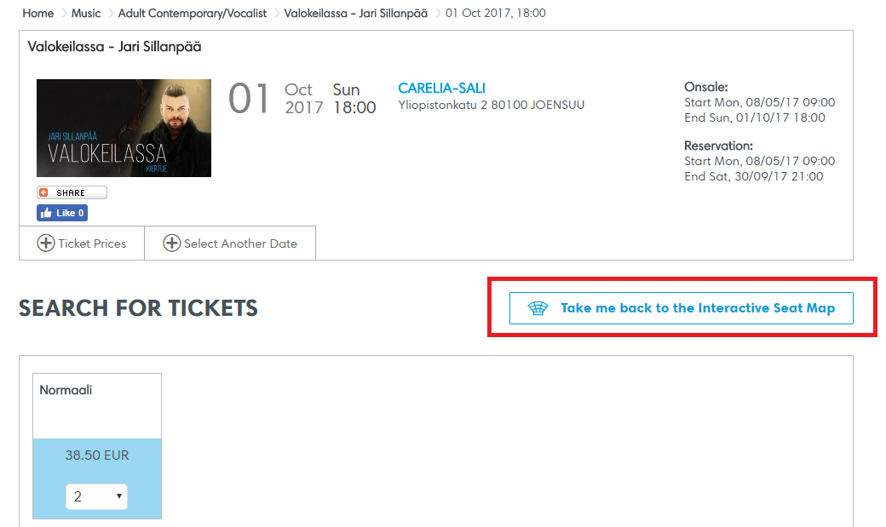**

**Mobile**

* On the default view, options to see either the seatmap or best available views are displayed. The user is required to select a view before tickets can be selected

Default view

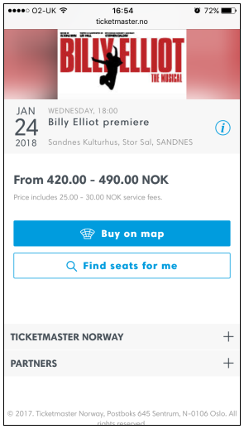

**SEATMAP MOBILE BELOW**

View when seatmap is selected is below. Clicking ‘x’ displays the default view. A direct link to best available isn’t displayed

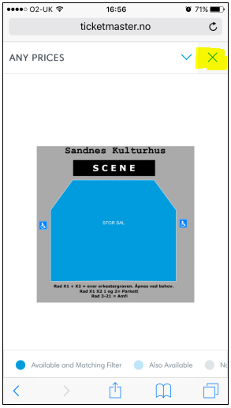

**BEST AVAILABLE BELOW:**

View when best available is selected is below. Clicking the seat map button will display the seatmap view

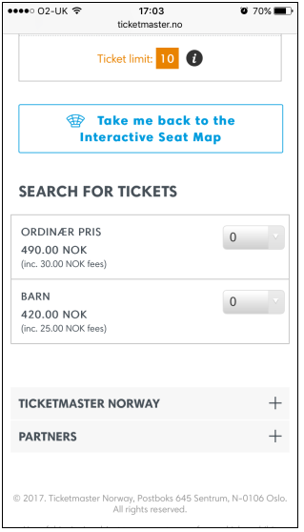

**Variant 1**

**Desktop:**

* Remove the toggle
* The Seatmap view will be the default
* It will not be possible to view the best available version

**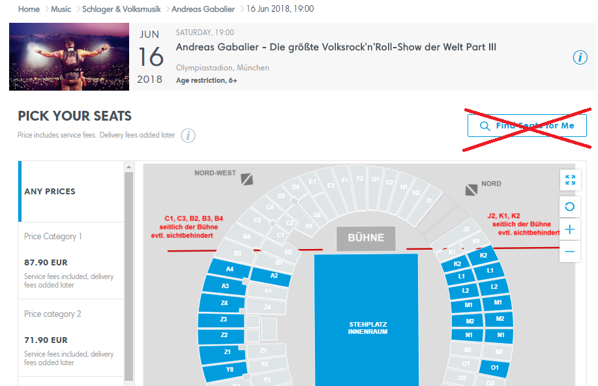**

**Mobile:**

* Remove the find seats button from the selection page below. No other changes
* Clicking the buy on map button displays the seatmap view (as per the default)

**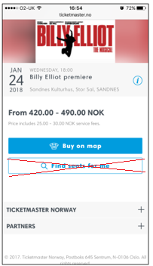**

* As per the default, clicking ‘x’ below will display the selection page



**Variant 2**

Existing button design with copy variations. No changes to the button design. Text changes only.

**Desktop & Mobile**

Default copy – as per live site

**Copy 1**

Find Seats For Me

Buy on Map

**Screenshot:**





**Variant 3**

**Copy 2**

Select Your Own

Best Available

**Variant 4**

Replace button with simple text link. Plus copy variations below. Use the font displayed in the current button

Default copy – as per live site

**Copy 1**

Find Seats For Me

Buy on Map

**Screenshot:**

TBC

**Variant 5**

**Copy 2**

Select Your Own

Best Available